Domayne’s Wooden Rebirth

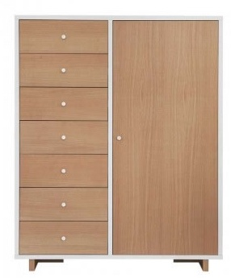

|  |
| --- |
| **DESCRIPTION** |
| Domayne’s dream designing has introduced an extra wide multi storage cupboard with extra griped surface. The cupboard has a nice feel with smooth surface and the brown color gives it a natural look which enables it to give a relaxing feeling. It will give your house a complete different look and a door with group of chests enable it store as well as hang goods. |

|  |  |  |
| --- | --- | --- |
| **Price** | **650$** | |
| **Dimensions** | **H** x **W** x **L** | **75in x 22in x 45in** |
| **Features** | **Extra long legs improve gravity of the cupboard so that it does not fall to the ground give extra protection over children.** | |
| **Finished** | **Wooden Formica** | |
| **Available in** | **Brown and peach** | |